Catalyst 101: The Basics of Using Catalysts in VRLA Cells

Harold A. Vanasse Daniel Jones

Technical Director President

Philadelphia Scientific

Montgomeryville, PA 18936

Introduction

Over the past four years of producing and selling catalysts we have been asked many questions about their use in VRLA cells. A lot of confusion exists on the part of people who have problems with their batteries. They ask us many questions about the catalyst and whether it can help them with problems like capacity loss, cell dryout, and thermal runaway, to name a few. The purpose of this paper is to address questions like this and demystify the use of catalysts in VRLA cells by offering a simplified explanation of what is occurring inside the cell once a catalyst is introduced into it.

Throughout the paper, we will present data from a test that we have been running for the past five years. The data from this test has been presented before when the test was younger, but the data has been updated for this paper. We will also present a simplified explanation of polarization in an effort to describe what is happening inside the cell. Finally a simplified description of the problem that the catalyst solves will be presented. The data from the test has been woven throughout the paper and will serve to help illustrate the points we are making.

A Tale of Two Batteries

Test Setup.
Approximately five years ago two identical sets of six 125 Ah cells each were placed on float service per the manufacturer’s instructions (2.27 VPC). The two groups of cells were placed in a water bath at 90°F (32°C) and catalysts were installed into the cells of one group. We fitted all of these cells with gas collection apparatus to allow for measurement of the gas evolved from each cell. We also installed a reference electrode into one representative cell from each group. These cells were never boost charged and were capacity tested once in late 1999 and again in mid 2001. After the discharge tests were conducted, the cells were allowed to float back up to charge. On at least a weekly basis the cells’ float current, float voltage, conductance and gassing rates were measured. Negative and positive plate polarization readings were also taken for the two representative cells. In year four of the test a tear down inspection was conducted on the cells, which is where we begin.

Tear Down Inspection
Approximately one year ago, or four years into the test, a tear down inspection was conducted on all but two of the catalyst equipped test cells. The two remaining catalyst cells are still on test. Upon tear down of the cells, we found the catalysts equipped cells to be in very good condition with minimal signs of aging or wear and tear. However, the tear down of the non-catalyst equipped cells told a very different story indeed. Upon tear down we found signs of cell dry out and massive corrosion of the positive grid. In some cases the positive grids had separated from the positive strap. It was obvious that the non-catalyst cells had died of positive corrosion. The extent of difference between the two groups of cells was dramatic, but surely there must have been some data that would have prepared us for what we found. Cells just don’t fail to this extent without giving off some signs.

Capacity
Twice in the life of this test, capacity tests were performed on both groups of cells. As can be seen from Figure 1, the average capacity of the non-catalyst cells declined between the two tests while the average capacity of the catalyst equipped cells remained steady. More importantly, the January 1999 test told us that the non-catalyst cells were already below 80% capacity and could be considered failed. By May 2001 the non-catalyst cells were in even worse shape; some of the cells in this group had 0% capacity. The results of the capacity test were confirmed by what we found in the tear down test, which was conducted after the May 2001 discharge test. It is important to note that by January 1999 these cells were approaching only 3 years of age, what could have happened in the controlled environment of our lab to cause such dramatic failure? Note that we are running these tests at a warmer temperature (90°F) to accelerate the test. Using the Arrhenius equation we would expect life to be halved relative to a room temperature of 68°F.
Figure 1
Gas Evolution
VRLA cells have a reputation for dryout problems. The rate of water loss can be measured by collecting the gas emitted from the cell. Too high a gassing rate will predict premature cell dryout. Differences in the gas emission rates between the two groups were seen very early on in the test. From the beginning of the test, as shown in Figure 2, the non-catalyst cells consistently emitted approximately four times more gas than the catalyst cells. In the past, we had done life estimates, based on time to cell dryout using the gas emission data we had collected. In 1998, it was predicted that the control cells would have 3 to 5 years of life while the catalyst cells would have 25 years of life based on water loss alone.

Figure 2

Conductance
Conductance and other ohmic measurements are convenient tools to use to estimate the state of health of a battery. They do not tell the user exactly what is occurring in the battery, but they are useful when compared to a set standard for the particular battery being tested or when compared to a collection of measurements taken over time. They can give the operator an early warning of impending problems. Figure 3 presents the conductance readings taken over the life of the test for the two groups of cells. The data has been averaged to aid in presentation. It is clear that the non-catalyst cells have a lower conductance than the catalyst cells. Also the trend for the catalyst cells is much healthier than the non-catalyst cells. It should be noted that in Figure 3, there is a large jump in the conductance plots near week 156. This jump occurred as a result of switching to a different conductance meter. The change in the equipment is the reason for the discontinuity in the data and is highlighted on the graph.

Figure 3

Float Current
This is the most significant reading that we have presented thus far. Float current is a leading indicator that has a relationship to all of the other parameters we have measured thus far and it can be a very insightful tool. As can be seen in Figure 4, the float current for the non-catalyst cells is twice that of the catalyst cells. This is a clear sign of major differences between the two cell groups.

Figure 4

The significance of float current becomes even more important when the relationship to the other measured parameters, and to VRLA failure modes, is spelled out. In all cases, lowering the float current is beneficial to the cell. It must be made clear here that we are not talking about lowering the float current by adjusting the charger down. We are talking about lowering the float current drawn by the cell while the charger is set to the manufacturer’s recommended float voltage. It is widely understood that a lowered float current will reduce the amount of corrosion that takes place on the positive plate. A lowered float current will also reduce the amount of gas generated by a cell (less electrolysis), which in turn automatically reduces the rate at which it escapes the cell. This can slow down cell dryout, which can lead to higher cell conductance readings and longer cell life. A lower float current also means a much lower risk of thermal runaway, which is the result of an ever-increasing float current. If float current does indeed have far the reaching impact just stated, then it should be the single most important and telling parameter we measure.

Polarization.
This is also a significant reading, but it is also harder to obtain. We installed reference electrodes into one cell from each group because we wanted to see the polarization on the positive plate separately from the negative plate. Reference electrodes are used to measure plate polarizations, but they are very hard to work with and are not frequently used with VRLA cells. They can introduce gas leaks to the cell and it is a common occurrence for the tip of the reference electrode to lose contact with the plates over time.

As can be seen Table 1, there is a shift in the distribution of the charge towards the positive plate on the control cell. The negative plate is not polarized (0 mV) while the positive plate is receiving all of the charge (120 mV). In the catalyst cell, there is a better distribution of the charge.

 | Control Cell | Catalyst Cell
Negative Plate Polarization | 0 mV | -20 mV
Positive Plate Polarization | 120 mV | 100 mV
Polarization Data of VRLA Cells at 2.27 VPC and 90°F
Table 1

Polarization is important because plate polarization and float current are directly related. Understanding how they are related is the key to understanding what the catalyst is doing inside the cell.

How are Polarization and Float Current Related?

We start with a simplified review of the basics of polarization. Polarization is an electrochemical way of looking at the charge on each individual plate in a cell. When a plate is charged it is said to be polarized, conversely when it is discharged it is depolarized. The total charge being applied to the plates is calculated by comparing the charge voltage to the open circuit voltage. In our test, the float voltage is 2.27 Volts and the open circuit voltage is 2.15 Volts. Subtracting one voltage from the other gives us the amount of overvoltage that is being applied to the cell to maintain its state of charge. The overvoltage for the cells in our test is 120 mV.

Float Voltage 2.27 V

Open Circuit Voltage 2.15 V

Overvoltage 0.12 V or 120 mV

Using data collected from the reference electrode we can determine how this overvoltage is split among the plates. Optimally, each plate will receive a portion of the overvoltage with the positive plate receiving the most. This is very important because if the positive plate receives too little voltage then it will not be properly charged and if it receives too much voltage then its corrosion will be accelerated. J.J. Lander developed a widely used curve to describe this relationship. Figure 5 is a Lander curve of positive grid corrosion versus positive plate polarization. This curve was not developed with the cells from our test, but is used here as an illustration.

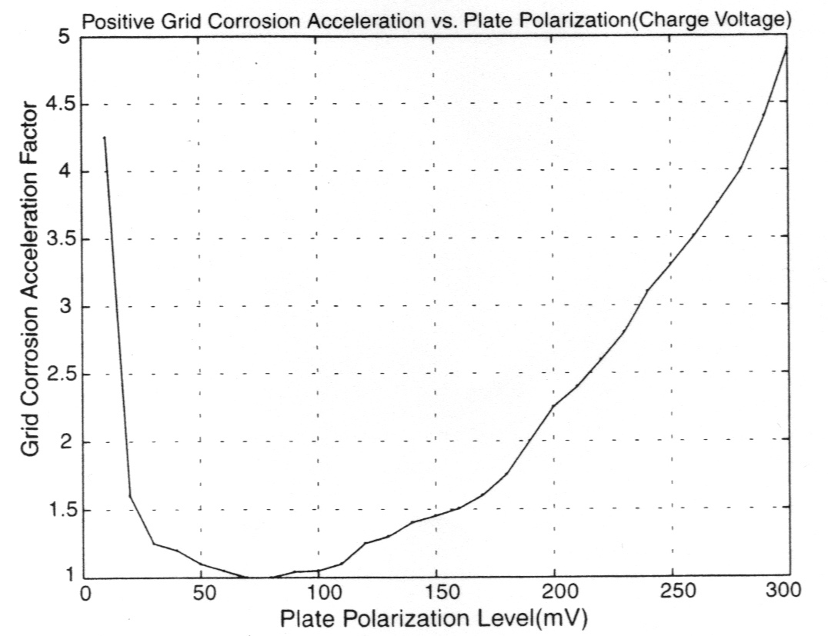
Figure 5

As can be seen from the Lander curve, around the 70 mV point is where positive grid corrosion is minimized. Polarizations above or below this point act to increase the corrosion of the positive plate. Coincidentally, a similar relationship can be made to the float current drawn by the battery. Dr. Berndt describes this relationship with the Tafel diagram presented in Figure 6.

As can be seen in this diagram, the higher the polarization of the positive plate the greater the current drawn by the battery. According to the Tafel diagram in Figure 6, a 120 mV positive polarization will draw 55 mA/100 Ah whereas a 100 mV polarization will draw only 35 mA/100 Ah. By reducing the positive plate polarization the float current was also reduced, in this case by 20 mA/100 Ah. It should be noted that Figure 6 was not developed with the cells from our test, but is used here as an illustration.

In a VRLA cell, if the negative plate can be polarized it will automatically reduce the polarization of the positive plate. Remember that the total overvoltage of the cell is divided among the positive and negative plates. What does not go onto the negative plate goes onto the positive plate. In the test that we have been describing, the non-catalyst cells had the entire 120 mV of overvoltage on the positive plates while the catalyst cells had 100 mV on the positive plate and 20 millivolts on the negative plate. It should not be surprising that the float current of the non-catalyst cell is two times higher than the catalyst cells. The non-catalyst cells had a higher positive polarization and therefore must have a higher float current. Keeping the negative plate polarized is therefore key in lowering the float current because it acts to reduce the positive plate polarization, and minimize positive plate corrosion while it is at it.

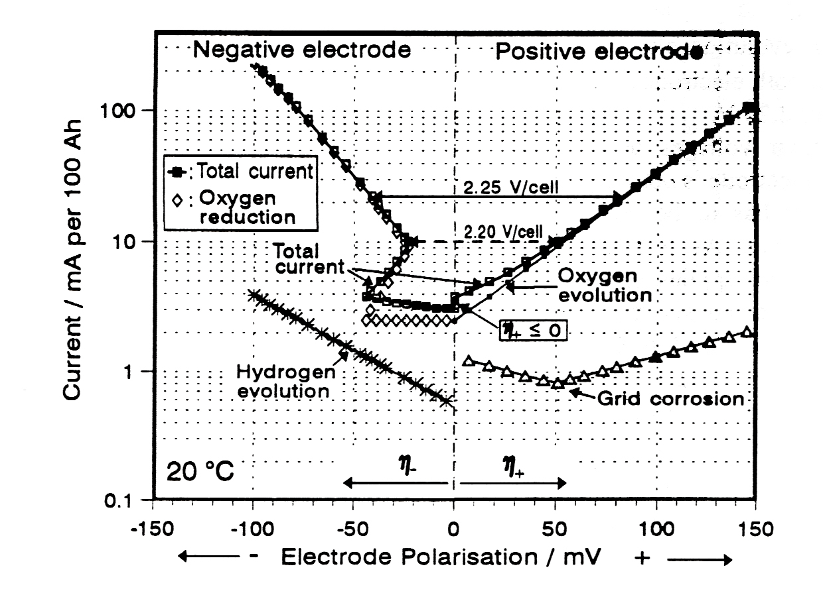
Figure 6

Now that we have made the link between polarization and float current, and have presented data to show that installing a catalyst into a cell can lower the positive polarization by maintaining a negative polarization, it is time to take the next step and explain how exactly the catalyst does this.

Negative Plate Self Discharge

To explain what the catalyst does in a VRLA cell to maintain the polarization of the negative plate, we must start with some simplified battery facts for VRLA cells:
- Hydrogen gas (H₂) is produced on the negative plate.
- Oxygen gas (O₂) is produced on the positive plate.
- Oxygen, hydrogen ions, and electrons are recombined on the negative plate to form water.
- When oxygen reaches the negative plate it causes a reduction in the polarization of the plate.
- While the cell is on float charge, a portion of the charge current will try to increase the polarization of the negative.

The last two facts point out that there is an electrochemical balancing act occurring inside the cell. If the depolarizing effect of the oxygen overpowers the polarizing effect of the charge current, the negative will slowly descend to a depolarized state.
There is also another contradiction in that a VRLA cell was designed to optimize the transport of oxygen to the negative plate so that it can recombine with hydrogen to form water. It was intended that this would keep the water in the cell and prevent cell dryout. However, oxygen will depolarize the negative plate in the process. So the easier it is for oxygen to get to the negative plate the more likely the balance will be thrown in favor of depolarizing the negative plate. The problem is that too much oxygen reaches the negative plate and discharges it – despite the fact that the negative plate is being float charged.

This problem is unique to the VRLA design; it was not known in flooded lead acid batteries because the liquid electrolyte naturally slows down the transport of oxygen from the positive to the negative plate. The liquid electrolyte also traps some of the oxygen as dissolved gas, which is a way to prevent the oxygen from reaching the negative plate altogether.

There are multiple ways to solve the problem of too much oxygen getting to the negative plate in VRLA cells. As we have already stated, there is an electrochemical balance act occurring on the negative plate between the depolarizing effect of the oxygen and the polarizing effect of the charge current. The polarizing charge is coming from multiple sources such as the corrosion of the positive plate and from the incoming charge current itself. One way to solve the depolarization problem would be to increase the corrosion rate of the positive plate, which would supply more charge to the negative plate. The downside to this is that the life of the battery would be shortened due to corrosion problems.

On the depolarizing side of the balance, there is another depolarization agent that could be considered in finding a solution to the problem. The polarization of the negative plate is directly affected by the chemical self-discharge of the lead that makes up the plate. The lead over time loses its charge as it interacts with the electrolyte. This source of depolarization is primarily affected by the purity of the lead itself; the higher the purity of the lead the lower the depolarizing influence. This solution is technically possible, but may be financially impractical and runs against the trend of increasing the use of recycled lead.

A relatively simple solution to the problem is to mimic what the liquid electrolyte does by preventing some of the oxygen from reaching the negative plate. A catalyst is an easy way to do this. A catalyst inserted into the headspace of a VRLA cell will recombine a small amount of the oxygen with the abundant hydrogen present to form water, which is then kept in the cell. By preventing a small amount of the oxygen from reaching the negative it allows the negative plate to maintain its optimal polarization. This is again illustrated nicely by the polarization data in Table 1. As we have already described, a higher negative polarization leads to a lower positive polarization, which will lead to a lower float current.

Conclusion

VRLA cells can be confusing to work with because there are many interrelated factors working together and many of them are hidden inside the cell and can’t be measured or observed easily. This paper has attempted to explain some of the factors and the connections between them. Once these relationships are understood, the beneficial effect of the catalyst can be understood. Figure 7 diagrams the connections between the topics discussed. Using our understanding of the various reactions we can formulate a common sense approach to the problems of VRLA reliability.

First, take a very keen interest in the float current. Low float current is good. It is a foundation for good health in a VRLA cells. Lower float current means slower positive plate corrosion. Lower float current means less gassing leading to dryout. Lower float current means less risk of thermal runaway. Float current is relatively easy to measure and it is a quick indicator. It may take years before a measurement of water loss or positive plate corrosion could be made that would indicate a problem. By then the damage has been done. In our tests, float current will stabilize very quickly and can be used as a leading indicator.

Float current that is too high can be caused by a cell that is out of balance. By that we mean that the polarizations on the positive and negative plates are not at their optimum points. The negative plate should be polarized at 20mV to 40mV and the rest of the polarization should go to the positive. If the negative becomes fully depolarized then the positive will absorb all the overvoltage and it’s polarization becomes too high. The excessive polarization of the positive is what causes the increase in float current.

The catalyst is a protector of the negative plate. It sits in the headspace of the cell and takes in a small amount of the oxygen generated at the positive plate and combines it with hydrogen to form water. That means there is less oxygen available to reach the negative plate and depolarize it. The negative stays polarized. There is a lower polarization on the positive. Thus the float current is lower, the corrosion rate is lower, and the cell is a healthy cell.

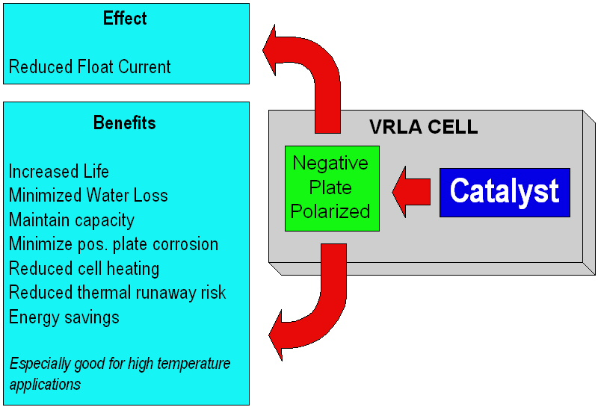

Figure 7

Jones, W.E.M., et al, “Can VRLA Batteries Last 20 Years?,” 1998 Intelec Proceedings.
Jones, W.E.M., et al, “Can VRLA Batteries Last 20 Years?,” 1998 Intelec Proceedings.
Berndt D.; Jones, W.E.M., “Balanced Float Charging of VRLA Batteries by Means of Catalysts,” 1998 Intelec Proceedings.
West, S, Krein, PT, “Equalization of Valve-Regulated Lead-Acid Batteries: Issues and Life Test Results,” 2000 Intelec Proceedings.
Berndt, D, “Maintenance Free Batteries, Lead Acid, Nickel/Cadmium, Nickel/Metal Hydride,” pps. 291-293, John Wiley & Sons, Inc., New York. 1997.

